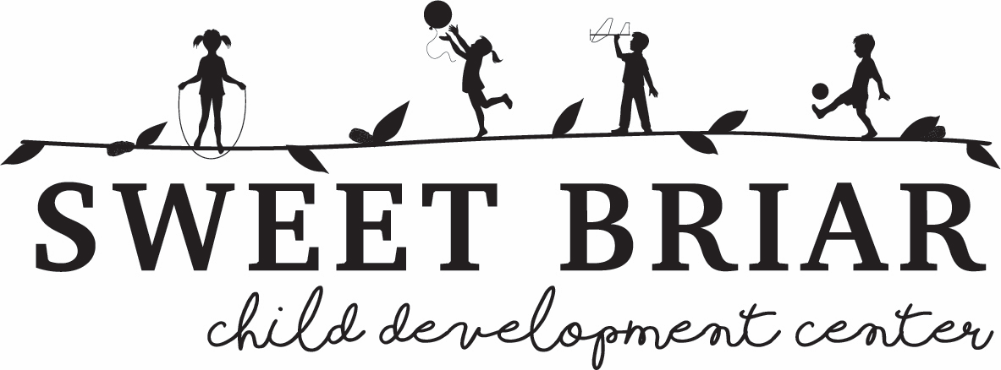

**Photo/Video Consent Form**

*Sweet Briar Child Development Center sometimes takes photographs, audio or video footage for educational purposes and occasionally for publicity and/or advertising purposes. Any letters, e-mail, and other written material made from you and addressed to us, such as letters of recommendations, testimonials about our program, etc. may also be used. These may appear in our printed publications, on our website, etc. Before taking any pictures, audio, or video footage or using written correspondence for these purposes, we need your permission. Please read and sign the form below where shown.*

I, ________________________, the parent/legal guardian of _______________________, do hereby authorize and consent to the use of photos, video, or audio recordings of myself or of my child by *Sweet Briar Child Development Center for* educational or promotion purposes, including, but not limited to, print, audio, video, and web promotion. I also agree that any writing or other material in connection with *Sweet Briar Child Development Center* including any correspondence from our family may be used in promotional materials.

I agree that all such portraits, pictures, photographs, video, and audio recordings shall remain the property of *Sweet Briar Child Development Center* unless otherwise noted. In addition, I waive all claims to compensation or damages based on the use of my or my child's image, correspondence, or voice by *Sweet Briar Child Development Center* I also waive the right to inspect or approve the finished product.

I attest that I have read this consent form and fully understand its contents.

_______________________________________________ _____________________________

Signature of Parent/Legal Guardian Date